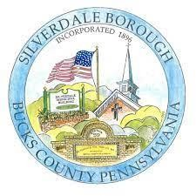

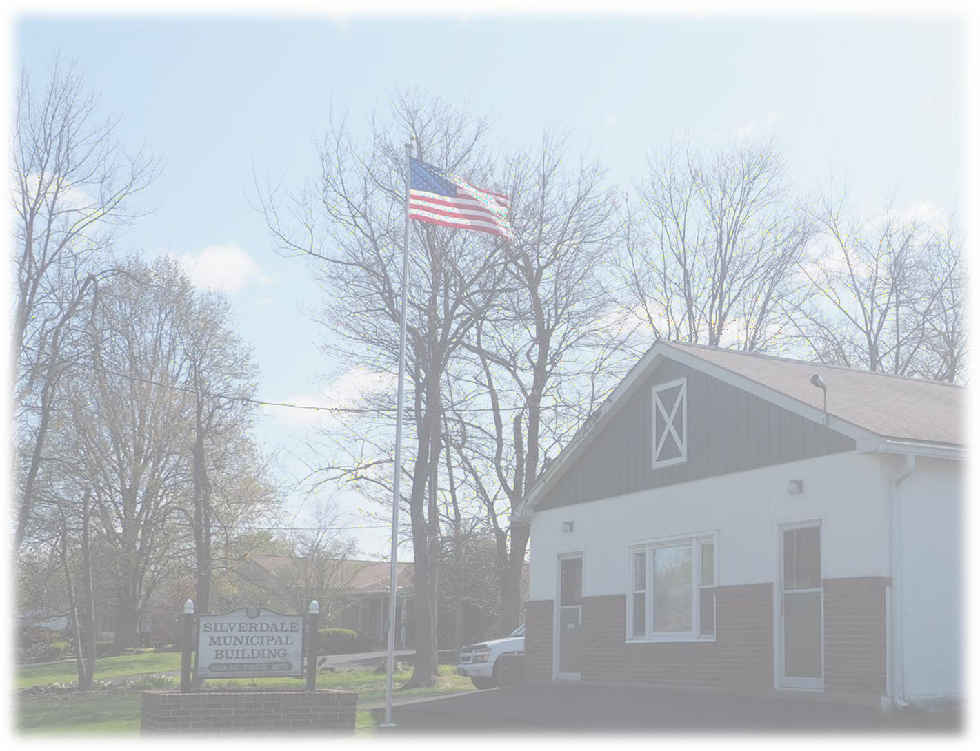Draft –September 2022
The Borough of Silverdale
2022 Implementable Plan Update to the 2016 Comprehensive Plan
Prepared by:

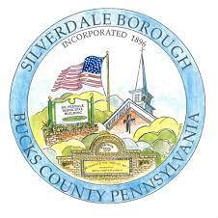
The Borough of Silverdale
2022 Implementable Plan Update to the 2016 Comprehensive Plan

Mayor
Steven Cordell

Borough Council
Claire Black, President
Stanley Krotowski, Vice President John Clark
Andy Constanzer Amy Montgomery David Alderfer
Steve Cassel

Planning Commission Thomas Heckler, Chair Matthew Rosa, Vice Chair Kenny Jones
Scott Lambrecht Ronald Landes Amy Montgomery James Pruitt

Borough Secretary/Administrator
Lisa Herrmann

Silverdale Community & Economic Development Committee
Steven Cordell, Mayor Andy Constanzer
Tara Sipe Rocky Wright
Stephen Barth, Barth Consulting Group
Lisa Herrmann, Borough Secretary/Administrator

Prepared by:

TABLE OF CONTENTS
Introduction 3
Process 4
Implementable Actions and Plan Revisions 7
Chapter 2: Population and Housing 7
Population Trends 7
Population Characteristics 8
Housing Characteristics 9
Housing and Population Forecast 10
Chapter 8: Statement of Objectives for Future Development 11
Existing Land Use 12
Future Land Use 12
Population and Housing 14
Plan Implementation 15
Figures
Figure 1. May 2022 Town Hall Community Workshop Consensus 6
Tables
Table 1. Population Change in Silverdale Borough, 1950–2020 7
Table 2. Age Cohorts, Silverdale Borough, 2000—2020 8
Table 3. Housing Characteristics, Silverdale Borough and Bucks County, 2020 8
Table 4. Units in Structure, Silverdale Borough and Bucks County, 2020 9
Table 5. Housing Occupancy and Tenure, Silverdale Borough and Bucks County, 2020 9
Table 6. Financial Characteristics, Silverdale Borough and Surrounding Municipalities, 2020 10

INTRODUCTION

Silverdale Borough is located entirely within the boundaries of Hilltown Township and is situated at the crossroads of State Route 113, (Main Street) and State Route 152, (Baringer Avenue and East Walnut Street). Just to the northwest are the boroughs of Perkasie and Sellersville. The 0.45-square-mile borough was incorporated in 1896 from Hilltown Township and has a current population of 805 people, according to the 2020 Census. The borough last updated its comprehensive plan in 2016.

Silverdale Borough is facing financial uncertainty. With only 325 tax-paying properties, general fund revenues no longer keep pace with inflation and rising expenses, nor do they provide adequate reserves to provide quality of life improvements, such as sidewalks, open space, paved roads, etc. Facing this challenge, Silverdale has opted to follow an “implementable comprehensive plan” update process. This process is driven by directly engaging the community through enhanced public participation to identify the most pressing issues facing the community and develop resident-embraced solutions.

The 2016 Silverdale Borough Comprehensive Plan notes in its introduction that “There is virtually very little vacant land remaining in the borough upon which new development can occur. Thus the approach to his comprehensive plan is to provide a cursory examination of existing conditions in the borough upon which a statement of community goals and objectives will be based.”

While very little vacant land may be available, land development trends in Bucks County between 2016 and 2022 have proven that land does not need to be vacant to be developed or more

THE MOST SIGNIFICANT ACTION ITEM IDENTIFIED IS THE BOROUGH’S NEED TO RAISE GENERAL
FUND REVENUE.

importantly, redeveloped. Many older boroughs and even larger townships are seeing an increase in the redevelopment of underperforming or long-vacant existing retail centers, and “main street downtowns”. This is particularly prevalent when land values become more valuable than the structures upon them. For developers, assembling and consolidating lots becomes the goal to knock down and start over to ensure a positive return on investment. The Dublin Town Center in Dublin Borough is a recent example of this trend.

The current financial situation, when coupled with resident wants and needs, dictates that the borough prepare an update to the 2016 plan that addresses future land use and revenue stability. Preparing an implementable comprehensive plan update serves two important functions:

- The planning process allows elected officials, appointed officials, and residents to freely discuss what the future of the borough should and could be. This discussion needs to be grounded in facts about the current conditions and elevated by the aspirations of community members about what the character and quality of the community should be in Silverdale Borough.

- The plan will form the basis for decision making, priority setting, and updating local codes and ordinances.

At the time this plan update was prepared, the borough had also engaged with Barth Consulting Group (BCG) to prepare an economic development plan for the borough’s future. Through a series of meetings and surveys, public input was gathered. From this work, and that of the BCPC staff in coordination with

the Silverdale Borough Planning Commission, action items were identified as priorities for implementation and changes to the current 2016 Comprehensive Plan.

This Implementable Plan Update will serve as a companion to the 2016 plan which largely remains relevant except for Chapter 2, Population and Housing, and certain portions of Chapter 8, Statement of Objectives for Future Development. The revisions to these two Chapters will be based on community- identified action items and the financial needs of the borough as highlighted by the work of the BCPC and BCG. The most significant action items identified are the borough’s need to raise revenue and allow for future growth and development.

How and where to accomplish this is the subject of this 2022 Silverdale Borough Implementable Comprehensive Plan update.

PROCESS

The borough contracted with Barth Consulting Group (BCG) in 2021 to assist with preparing an economic development plan for the borough. The most significant cost to the borough comes from the ongoing arrangement with Hilltown Township to provide police protection for borough residents. These costs rise annually by 5 percent per the contract and represent 40 percent of the borough’s expenses. In 2019, Silverdale raised taxes by 6 mills. Prior to that, property taxes had not been raised in 50 years. Silverdale Borough’s taxes remain amongst the lowest in the County.

BCG in collaboration with the Silverdale Community & Economic Development Committee (SCEDC), facilitated two resident surveys to garner resident input on several quality of life items, as well as future development. The first survey was administered in June 2021 and had a 61 percent response rate. The survey provided a glimpse into resident desires that echoed and reaffirmed many of the goals and objectives of the current 2016 plan, such as providing sidewalks and traffic calming measures.

In March of 2022, the SCEDC issued a second survey to succinctly illustrate the financial crisis facing the borough and to determine how residents wanted to solve the problem. Through a series of questions, residents were presented with options including:

- Mix of housing, non-residential development, and tax increases
- Raise taxes incrementally
- Encourage new housing development
- Combination of housing and tax increases
- Non-residential small business development
- Do nothing new

The second survey received a 41 percent response rate and was sent to every household in the borough. Based on the results of the second survey, residents favored a fixed annual increase per taxing property every year over the next five years and to allow for a mix of new housing and new commercial development which could include mixed-use developments. Mixed-use developments are designed to promote a harmonious combination of residential and non-residential retail and service uses incorporating efficient use of land, improved community spaces, and increased pedestrian access. This was the community-identified course to raise revenues and put Silverdale on a secure financial footing.

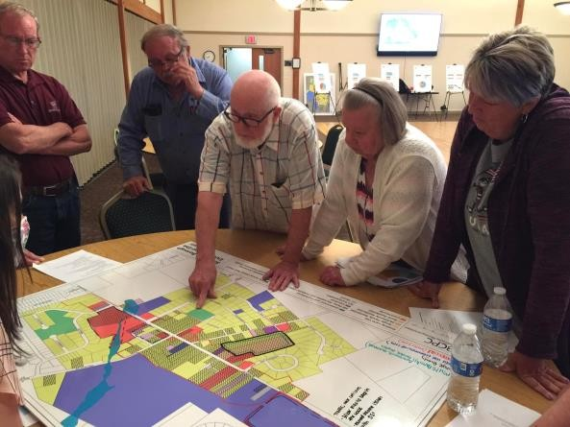On May 24, 2022, the BCPC co-facilitated a community workshop with BCG to engage the community in a mapping exercise based on the results of the second survey. An overview of the borough was presented and examples of various mixed-use developments were also presented to stimulate creative thinking and visioning. Meeting participants were then assembled into three groups all with the same map of the borough. The maps showed existing land uses in the borough and were laminated to utilize dry-erase markers. Using the dry erase markers, residents were asked to identify the areas of the borough where they would like to see additional housing development and areas for new mixed-use development.
Picture 1: May 2022 Town Hall Mapping Activity

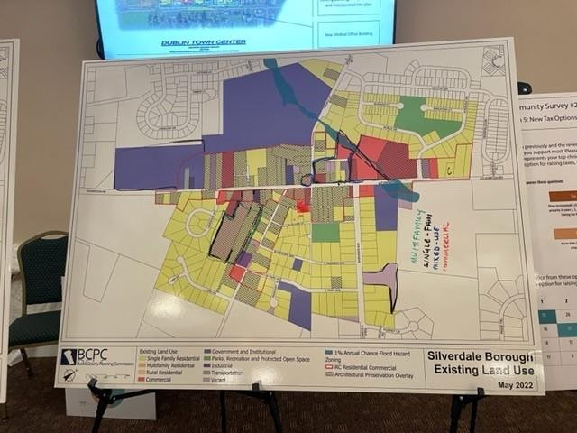After the meeting, all three group maps were compared and identified identical solutions as to where development should occur. A consensus was reached and a pathway to an implementable plan was identified.

The three groups reached the following conclusions:

Picture 2: May 2022 Town Hall Mapping Activity Results
Mixed-use development along the north side of Main Street, between Walnut Street and Sterling Drive, was agreed upon by all three groups at the meeting. This area of the borough was the most talked-about area with residents seeing it as the area with the most potential for development or
redevelopment in the borough.

A second area along the south side of Main Street between Walnut Street and Baringer Ave was discussed after the group meetings, as another potential area for mixed-use development as it contains nearly 5 acres that could be developed as or with a town center.

Residents saw an opportunity for higher density housing, either townhomes or multifamily, on the three larger parcels south along Main Street and West of Green Street. There was some discussion about whether access to that potential development should be along Main Street or Green Street, and most residents agreed there would need to be an access via Main Street. It was brought up that the addition of housing in these parcels may benefit the borough to create a more cohesive residential neighborhood, rather than allowing for commercial development along Green Street.

There were also conversations about changing the uses allowed in the R Residential District for the parcels along Green Street between West Park Avenue and Main Street as shown in Figure 1. This included potential rezoning to the RC Residential-Commercial District. After the public meeting, a review of the current R District Zoning revealed that certain home-based, low-impact businesses are already permitted

“by-right” through the zoning ordinance. As a result, this concept was abandoned and the action items shifted to one of enforcement by the borough code official to ensure that existing commercial uses in these properties and others in the R District are in compliance with the applicable codes.

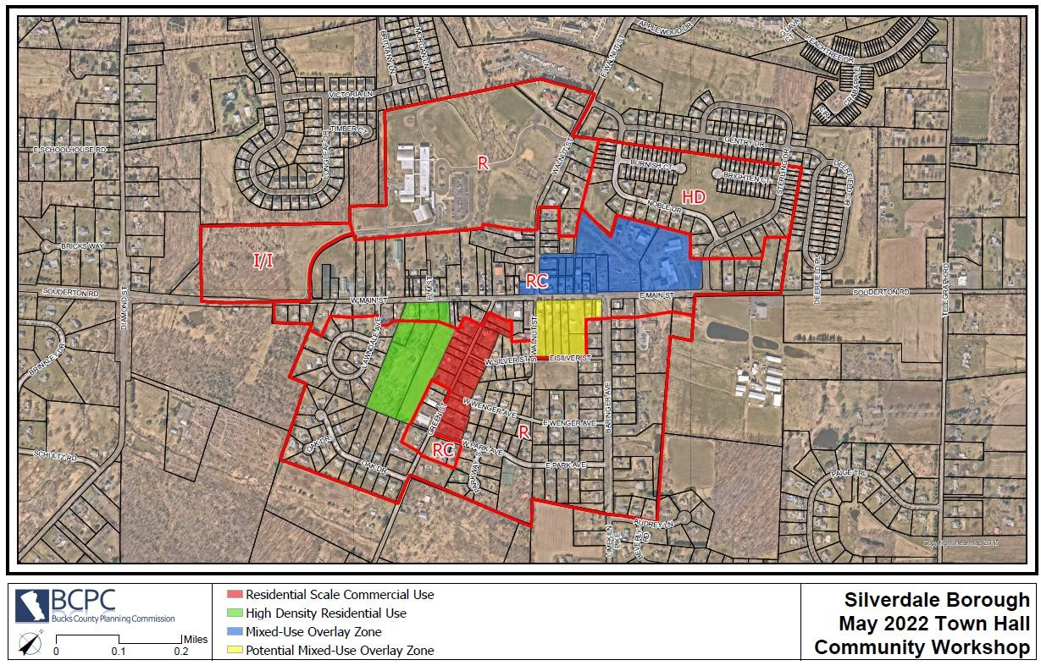
Figure 1. May 2022 Town Hall Community Workshop Consensus

IMPLEMENTABLE ACTIONS and PLAN REVISIONS CHAPTER 2: POPULATION AND HOUSING
Since the adoption of the 2016 plan, the 2020 Decennial Census was completed and new population forecasts are available from the American Community Survey (ACS), as well as the Delaware Valley Regional Planning Commission (DVRPC). We note that at the time this update was prepared, the 2020 Census detailed demographic data was still unavailable from the US Census Bureau. Where applicable, ACS data has been used to compile relevant forecasts. Given the borough’s need for increased revenue and the community’s desire to accommodate new housing development, an update of the borough’s population and housing characteristics is appropriate.

For Silverdale Borough, the amount of vacant land that is in private ownership and has potential for development with new residential units is very limited. There are however, opportunities for redevelopment of existing underdeveloped or underperforming parcels. New land development is needed to stabilize revenues. This new development may contain new housing units. While a significant population increase is not anticipated, some incremental and steady increases in population are reasonably anticipated. This may be further augmented through organic housing turnover in which younger families move in and occupy homes previously occupied by older persons without children.

Population Trends

In the five years since the 2016 plan was adopted, and based on a comparison of the 2010 and 2020 Census data, the borough’s population has declined. The population decline began in 2000 and the borough’s population is down by 20 percent from its peak in 2000 when there were 1,001 residents in the borough. The 2015–2045 DVRPC population forecast for the borough had a population of 863 projected for 2020. This was approximately seven percent higher than the actual census numbers.

Table 1. Population Change in Silverdale Borough, 1950–2020
Year | Population | Amount of Change | Percentage Change
1950 | 384 | - | -
1960 | 489 | 105 | 27.3
1970 | 545 | 56 | 11.4
1980 | 499 | -46 | -8.4
1990 | 881 | 382 | 76.5
2000 | 1,001 | 120 | 13.6
2010 | 871 | -130 | -13.0
2020 | 805* | -66 | -7.6
Sources: U.S. Census 1950–2010, and *2020 US Census

Population Characteristics

According to the 2020 US Census, the borough remains predominantly White at 96.27 percent with the remainder comprised of Black/African American, Asian, or some other race alone.

In 2010, the majority of the population (667 persons, or 76.6 percent) of Silverdale Borough was between 0 and 55 years old. However, by 2020, 632 persons, or 70.1 percent were under 55 years of age.

Table 2. Age Cohorts, Silverdale Borough, 2000—2020
Age Cohorts | 2000 |  | 2010 |  | 2020
 | Number | Percent | Number | Percent | Number | Percent
Under 5 | 65 | 6.5 | 43 | 4.9 | 38 | 4.2
5 to 9 | 93 | 9.3 | 35 | 4.0 | 71 | 7.9
10 to 14 | 110 | 11.0 | 61 | 7.0 | 121 | 13.4
15 to 19 | 87 | 8.7 | 69 | 7.9 | 28 | 3.1
20 to 24 | 35 | 3.5 | 54 | 6.2 | 29 | 3.2
25 to 34 | 124 | 12.4 | 73 | 8.4 | 74 | 8.2
35 to 44 | 229 | 22.9 | 141 | 16.2 | 96 | 10.7
45 to 54 | 121 | 12.1 | 191 | 21.9 | 175 | 19.4
55 to 59 | 40 | 4.0 | 59 | 6.8 | 114 | 12.7
60 to 64 | 35 | 3.5 | 42 | 4.8 | 41 | 4.6
65 to 74 | 41 | 4.1 | 70 | 8.0 | 75 | 8.3
75 to 84 | 17 | 1.7 | 25 | 2.9 | 35 | 3.9
85 and up | 4 | 0.4 | 8 | 0.9 | 4 | 0.4
Total | 1,001 | 100.0 | 871 | 100.0 | 901 | 100.0
Sources: U.S. Census 2000—2010, American Community Survey 5-year estimates, 2016—2020

Table 3. Housing Characteristics, Silverdale Borough and Bucks County, 2020
Housing Characteristics | Silverdale | Bucks County
Median Age (years) | 42.8 | 44.0
Households | 316 | 240,763
Family Households | 3,239 | 173,010
Married Couple Families | 189 | 139,648
Nonfamily Households | 77 | 67,753
Householders Living Alone | 61 | 55,769
Average Household Size | 2.82 | 2.57
Average Family Size | 3.27 | 3.03
Source: American Community Survey 5-year estimates, 2016—2020

Housing Characteristics

According to the ACS, there are currently 324 housing units in Silverdale. Of those units, 80.55 percent are owner occupied and 16.97 percent are renter occupied. There are eight vacant housing units noted, however, this number is an estimate and is subject to change.

Table 4. Units in Structure, Silverdale Borough and Bucks County, 2020
Units in Structure | Silverdale Borough |  | Bucks County
 | Number | Percent | Number | Percent
Total | 324 | 100.0 | 251,373 | 100.0
1, detached | 218 | 67.3 | 161,054 | 64.1
1, attached | 93 | 28.7 | 39,372 | 15.7
2 | 8 | 2.5 | 6,033 | 2.4
3 or 4 | 1 | 0.3 | 5,956 | 2.4
5 to 9 | 4 | 1.2 | 8,647 | 3.4
10 to 19 | 0 | 0.0 | 9,357 | 3.7
20 to 49 | 0 | 0.0 | 6,985 | 2.8
50 or more | 0 | 0.0 | 9,166 | 3.7
Mobile home | 0 | 0.0 | 4,764 | 1.9
Boat, RV, van, etc. | 0 | 0.0 | 39 | 0.0
Source: American Community Survey 5-year estimates, 2016—2020

Table 5. Housing Occupancy and Tenure, Silverdale Borough and Bucks County, 2020
Housing Occupancy and Tenure | Silverdale Borough |  | Bucks County
 | Estimate | Percent | Estimate | Percent
Total housing units | 324 | 100.0 | 251,373 | 100.0
Occupied housing units | 316 | 97.5 | 240,763 | 95.8
Owner-occupied | 261 | 82.6 | 187,963 | 78.1
Renter-occupied | 55 | 17.4 | 52,800 | 21.9
Vacant housing units | 8 | 2.5 | 10,610 | 4.2
Homeowner vacancy rate | 0.0 | - | 0.7 | -
Rental vacancy rate | 6.8 | - | 3.7 | -
Source: American Community Survey 5-year estimates, 2016—2020

Table 6. Financial Characteristics, Silverdale Borough and Surrounding Municipalities, 2020
Financial Characteristics | Median Household Income | Median House Value of Owner- Occupied Units | Median Gross Rent | Percent Below Poverty Level
Silverdale Borough | $95,500 | $266,400 | $1,313 | 1.9
Bedminster Township | $118,074 | $421,700 | $1,750 | 0.8
Dublin Borough | $78,971 | $270,300 | $1,142 | 7.7
East Rockhill Township | $107,143 | $378,600 | $1,377 | 5.7
Hilltown Township | $104,685 | $342,400 | $1,662 | 3.9
Perkasie Borough | $79,293 | $263,100 | $1,005 | 9.4
Sellersville Borough | $69,976 | $220,400 | $1,098 | 11.1
West Rockhill Township | $100,648 | $350,700 | $996 | 5.6
Bucks County | $93,181 | $340,500 | $1,252 | 5.6
Source: American Community Survey 5-year estimates, 2016—2020

Housing and Population Forecast

Based on community input and the financial needs of the borough, new residential development is needed and expected. Given that there is little vacant land and the opportunity for redevelopment of underutilized and underperforming parcels exists in the borough, the amount of new growth and population growth can be reasonably estimated.

At the time this implementable update was prepared, the borough had already learned of a sketch plan for the parcel known as the “Baldwin Tract” (TMP #40-003-051). The proposal indicated the possibility of 40 townhomes. The borough is also aware that the owners of the parcel (TMP #40-003-056) located adjacent to the Baldwin Tract, are considering redevelopment as well. Should these two parcels be combined into one development, we anticipate that upwards of 50 new townhomes could be built. With the knowledge of the apartment development market, and desired unit counts of developers, we can reasonably anticipate upwards of 50 new apartments as part of a new mixed-use development scenario. The ultimate number remains to be determined. It should also be noted that at the time of this implementable update, the country was experiencing its worst inflation in 40 years with high-interest rates, major supply chain disruptions, a severe housing shortage, and a labor shortage. The effects of this market on new development and redevelopment remain unclear at this time, however, the borough is prepared to take action where necessary.

CHAPTER 8: STATEMENT OF OBJECTIVES FOR FUTURE DEVELOPMENT

Silverdale, a crossroads community, was incorporated as a borough in 1896. The town formed at the intersection of Souderton Road (PA Route 113) and Limekiln Pike (PA Route 152) in the north-central part of Hilltown Township. Today, the two regional roads carry volumes of traffic through the borough that could not have been envisioned 50 years ago. At this point in its history, Silverdale has very little land that is undeveloped or vacant. Recent trends in land use within Bucks County suggest that older established boroughs such as Silverdale, are experiencing redevelopment of underperforming sites, not just new development of vacant land. As land values increase, often it is economically prudent to demolish an existing underperforming building and reimagine the site with a new use and purpose. This coupled with the borough’s financial prognosis served as the impetus for this update.

The potential for new residential units to be built and for the population to increase in the years to come is somewhat limited but possible when considering a redevelopment scenario. Over the past 20 years, the borough’s population has generally declined from its highest point of 1,001 residents in 2000. Population forecasts from the DVRPC and the ACS further confirm this trend. The borough will continue to be impacted by development and redevelopment which occurs within neighboring municipalities such as Hilltown Township, Perkasie Borough, and Sellersville Borough, specifically with regards to increased traffic flow on Main Street (State Route 113) and Baringer Avenue (State Route 152). Silverdale desires to remain a viable community that will provide a good quality of life for its residents.

This comprehensive plan update was prepared to examine the current state of the community and to identify issues that are and will be facing the borough. The financial future and economic stability of the borough have been identified as critical elements. The borough’s ability to continue to provide current levels of services and to pursue the quality of life improvements desired by its residents are no longer sustainable long-term, based on the current level of taxation and ratable properties.

Based on the work of the BCG and the BCPC, this Statement of Objectives has been updated as applicable. The Statement of the Goals and Objectives provide an overview of the borough and a framework and guide for making land use-related decisions that will face the elected officials not only today, but for years to come. The Comprehensive Plan serves as a policy guide for the review of the borough's zoning ordinance, subdivision and land development ordinance (SALDO), and overall land use strategy. The comprehensive plan should be referred to often as a guide to making decisions, and for measures that are needed to implement the recommendations contained herein. In addition, to remain viable and in tune with the conditions of the time, a comprehensive plan should be reviewed every ten years as recommended by the Pennsylvania Municipalities Planning Code (PA MPC).

The borough’s primary objectives are as follows:

  - To retain the atmosphere of a small borough while permitting gradual and planned growth through development and redevelopment while accommodating shifts in population and market trends;

  - To provide the local government the means and public facilities necessary to maintain a good state of repair and to provide for quality of life improvements desired by residents;

  - To cooperate with both the county and neighboring municipalities to further the goal of controlled and planned growth in Upper Bucks County;

  - To attract residential and mixed-use development consistent with the present architectural character and land use characteristics of the borough and in accordance with local codes;

  - To permit mixed-use commercial and residential development in appropriate areas of the borough and to amend zoning and related codes as applicable to facilitate these types of developments or redevelopments.

Existing Land Use

The Borough of Silverdale is primarily residential in character with a small mix of light retail and commercial usage. In recent years, growth in the borough has occurred at a very slow rate. This trend however, is changing as market conditions bring about the potential for redevelopment and the borough faces a need for new tax ratables to ensure long-term financial sustainability for operations.

Small businesses, automotive service facilities, and professional offices constitute the major commercial use. There is one new national “fast food” establishment. No industrial installations are located in Silverdale, with the exception of a small manufacturing establishment. There are at present more than 29 properties within Silverdale, which are used for non-residential commercial operations of some type. Most are single lots and some have more than one principal use on a single lot.

There presently is an existing water system that serves a portion of the borough. On-site wells constitute the other source of supply. The borough has public sewers and is connected to the Pennridge Wastewater Treatment Plant.

Other major facilities available to the borough include a school and fire protection. The Pennridge Central Middle School is located in the borough. Silverdale children are bussed to schools in the Pennridge School District and the Silverdale Volunteer Fire Company provides fire protection. Emergency medical services (EMS) are provided by Grandview Hospital, Chal-Brit Regional EMS, and other regional EMS providers based on availability.

Future Land Use

Recognizing that the financial future of the borough requires increased stewardship, Borough Council engaged with BCG in 2021 to review the borough’s finances and to assist with crafting a path forward that ensured financial solvency to maintain Silverdale as an independent municipal subdivision within Bucks County. The borough also engaged the BCPC in 2022 to assist with updating the 2016 Comprehensive Plan and assist with other planning matters.

Through a series of resident surveys, public workshops, and committee meetings, the public identified a desire for phased increases in property taxes coupled with allowing for a mix of residential and commercial development and redevelopment to supplement the borough’s tax base.

To facilitate future land use and economic sustainability, the planning commission recommends the following implementable actions:

- Preserve architecturally significant structures as identified by the Architecture Preservation Overlay Zone and where appropriate, allow for incorporation into new developments or demolition, where warranted, in accordance with existing ordinances;

- Create a Mixed-Use Overlay (MUO) District that will enable mixed-use development and redevelopment to occur. Mixed-Use shall include both residential and non-residential, commercial and retail uses, and shall permit them to occur within the same structure and on the same lot as applicable;

- Allow for the development of mixed-use commercial and residential developments along Main Street (State Route 113) on parcels that are undeveloped or underperforming based on market trends and needs of the community and to identify these parcels on the zoning map as part of a mixed-use overlay district;

- Prepare Design Guidelines for the RC District and MUO to articulate the desired aesthetic objectives for maintaining the borough’s unique architectural scale and character while ensuring that a pedestrian-oriented streetscape is created to facilitate non-vehicular access to local business;

- Examine existing ordinances to identify and include revisions that will allow for the desired types of non-residential and residential development and redevelopment, identified as preferred by the public;

- Rezone the Pennridge School District Parcel along North Walnut Street (State Route 152) from R residential to I/I Institutional/Industrial to eliminate the split zoning and more precisely match the land use with the applicable zoning district regulations;

- Where feasible, remove split zoning from parcels within the RC District to make them all RC Residential Commercial or all R, Residential as applicable based on adjacent zoning and potential for redevelopment.

- Update the borough’s zoning map to reflect applicable changes.

Population and Housing

In the history of the borough, the largest change in population occurred in the 1980s when the number of residents increased from 499 to 881, a 76.5 percent increase. The borough observed another significant population increase between 1990 and 2000 when the population reached its highest number with 1,001 residents. From 2000 to 2020 the population has generally declined with a significant dip in 2010 down to 871 from 1,001, a decrease of 13 percent. Based on the 2020 Census and current ACS data the borough’s 2020 population was noted as 901 or a 3.4 percent increase from 2010.

Absent the development of any new residential housing units, population forecasts for the borough’s population growth continue to show a small overall population decline of -1 percent from 2010 through 2050.

The amount of vacant land that is in private ownership that has some potential for development with new residential units is very limited. There are however opportunities for redevelopment of existing parcels. The need for more ratables and the public’s desire to see a mix of residential and non-residential mixed- use development and redevelopment suggest that the borough’s population is likely to grow modestly and may slightly exceed forecasts with population numbers closer to the year 2000 levels.

The ACS five-year estimates from 2016–2020 reveal that there are 324 housing units in the borough with a 97.5 percent occupancy rate. Of the 316 occupied units, 82.6 percent are owner-occupied. The average household size in 2020 was 2.82 persons. Based on the potential sites for additional residential development and mixed-used use development, and the housing forecast from Chapter 2, there is the potential for upwards of 100 new housing units within the borough. This is based on gross acreage, potential yield analysis, and some very preliminary concept plans. Using the 2.82 persons per household average household size, 100 new units could yield an additional 282 residents. The final number however is highly dependent on the inclusion of multi-family units in true mixed-use development, should that occur.

To facilitate future population and housing growth the planning commission recommends the following implementable actions:

- Review the borough's ordinances to ensure they are providing appropriate regulations that enable the development or redevelopment of a mix of housing unit types as part of a mixed-use overlay zone as applicable;

- Review the borough's ordinances to ensure they are providing appropriate regulations which enable infill development or redevelopment on vacant or underperforming parcels within the R district that is compatible with the housing in the surrounding neighborhood;

- Revise the R-Residential District to include a townhouse use on sites with a minimum gross acreage of five or more acres. Base use regulations on the townhouse use as permitted under the A4 Performance Standard Subdivision section of the zoning ordinance Section 404 Use Regulations.

- Enforce the existing code regulations regarding home-based businesses permitted in the R- Residential District as stipulated in Section B Accessory Residential of the zoning ordinance Section 404 Use Regulations.

PLAN IMPLEMENTATION

This document shall serve as a companion update to the current 2016 Comprehensive Plan dated January 4, 2016. The aforementioned sections shall replace existing sections, similarly named, in the current 2016 Comprehensive Plan. Chapter 8, Future Land Use shall be a new section added to the current comprehensive plan through this implementable update.

Going forward, the Silverdale Borough Planning Commission shall be the entity responsible for advancing and making the recommendations necessary to implement the outlined objectives within this plan update. The Silverdale Borough Council shall be the entity responsible for reviewing and approving all proposed zoning changes, zoning map amendments, and any further changes to the comprehensive plan as needed.

The Silverdale Borough Community & Economic Development Committee should continue to meet, regularly, and be the first stop for any new development proposed in the borough. The SCEDC should continue to update and inform the planning commission of necessary changes to the comprehensive plan or zoning ordinance, necessitated by new development proposals that are consistent with the objectives of Chapter 8.

